2) Create a simple deployment.yml and access the file

a) deployment.yml :

A deployment.yml file in Kubernetes defines a Deployment resource to manage and scale a set of Pods, ensuring the desired number of replicas are running.

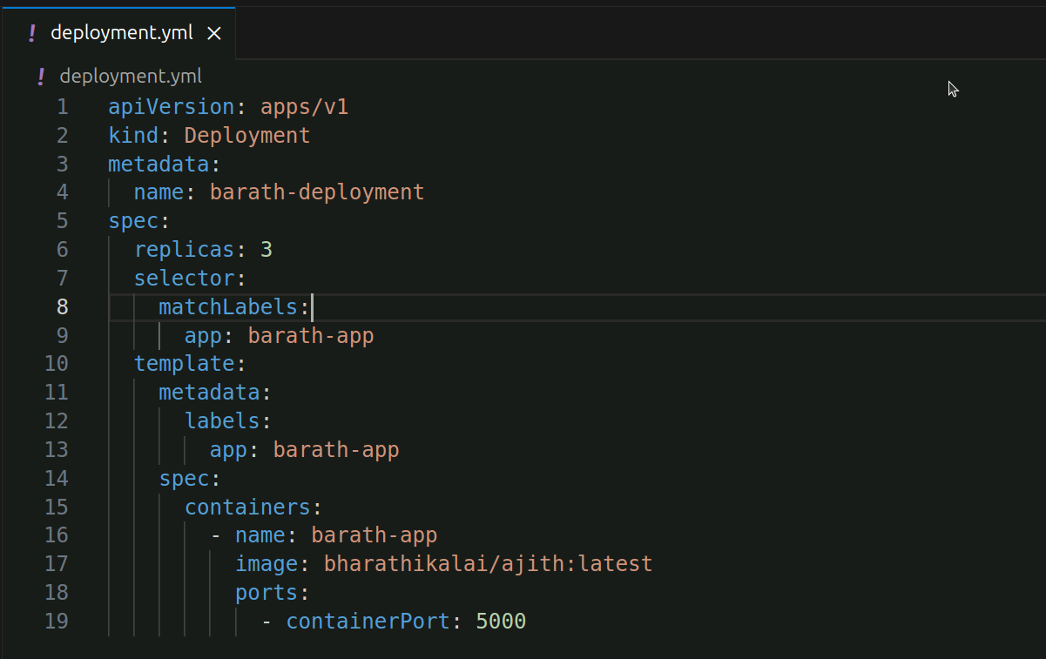

b)



C) Check pod status

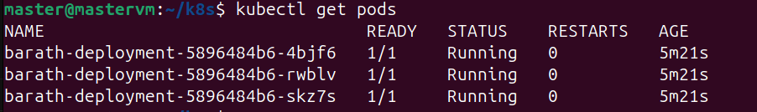

D) Check **ReplicaSets**



E) Remove one pod and check whether another pod is created automatically or not

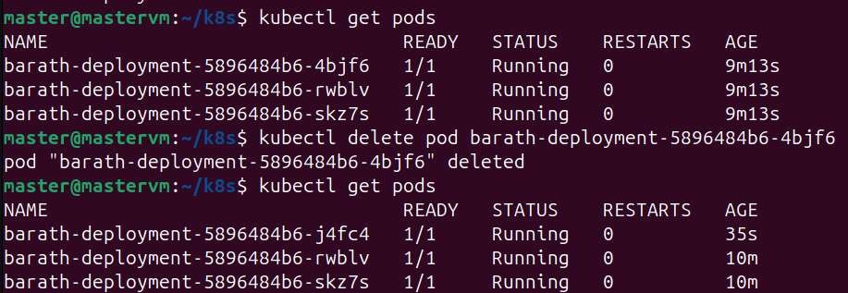

In this I have deleted the first pod and after I checked pod status another pod have created automatically.

F) Delete the deployment

